***+ANUDIP FOUNDATION***

A Project Report on

**TOURISM MANAGEMENT SYSTEM**

By

Batch: ANP-D0453

Student ID: AF0477069

Name: Naina Meragu

**Under the Guidance of**

Mrs. Rajshri Chandrabhan Thete

**TOURISM MANAGEMENT SYSTEM**

**Introducing our Java-based Tourism Management System (TMS):**  
Efficiently manage and oversee every aspect of tourism services with our intuitive system. From managing user registrations and booking tickets to handling bus schedules, tracking routes, generating reports, and collecting feedback, our Tourism Management System (TMS) empowers travel agencies and service providers to streamline operations, enhance customer satisfaction, and ensure smooth and efficient travel experiences.

**Entities**

* User
* Booking
* Report
* Ticket
* Bus
* Route
* Feedback

**ATTRIBUTES OF ENTITIES:**

1. **User**
   * **Primary Key: User_ID**
   * **Attributes : User_Name, Email, Mobile, User_Type**
2. **Booking**
   * **Primary Key: Booking _ID**
   * **Attributes: Booking_Title, Booking_Type, Date, RouteTo, RouteFrom, pickUpPoint**
   * **Foreign Key : User_ID**
3. **Report**
   * **Primary Key: Report _ID**
   * **Attributes: Report_Name, Report_Type**
4. **Ticket**
   * **Primary Key: Ticket_ID**
   * **Attributes: Status, Date**
   * **Foreign Key: Bus_ID, Booking_ID**
5. **Bus**
   * **Primary Key: Bus_ID**
   * **Attributes: Bus_No, Bus_Type**
6. **Route**
   * **Primary Key: Route_ID**
   * **Attributes: Route_To, Route_From, Pick_Up_Point, Date_Of_Journey**
   * **Foreign Key : Bus_ID**
7. **Feedback**
   * **Primary Key: Feedback_ID**
   * **Attributes: Date, Rating**
   * **Foreign Key : User_ID**

**ENTITY RELATIONSHIP DIAGRAM – TOURISM MANAGEMENT SYSTEM** 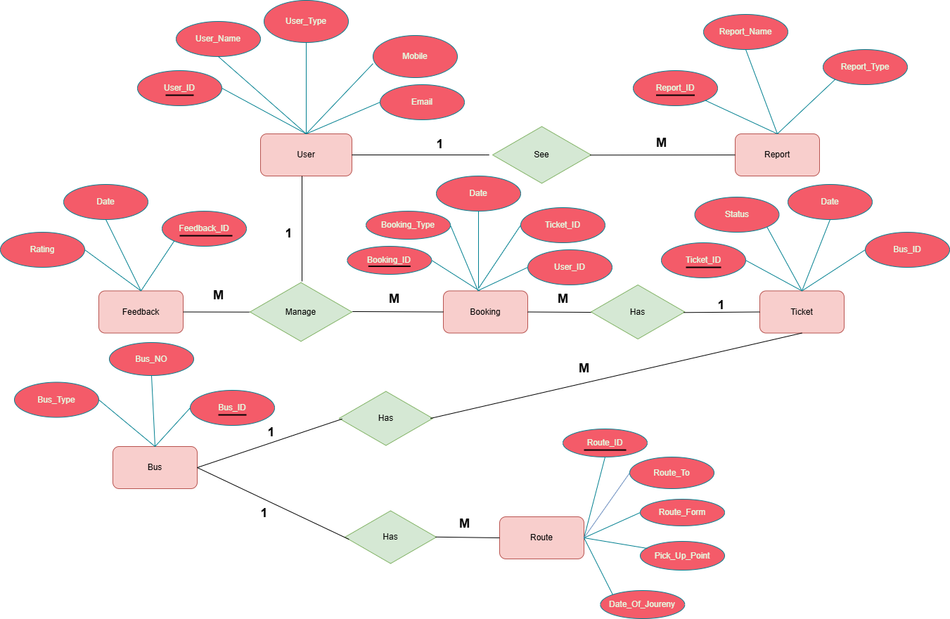

**CONCLUSION:**

In summary, the Tourism Management System (TMS) offers a comprehensive solution designed to optimize and automate various aspects of tourism operations. By integrating essential modules such as User management, Booking, Ticketing, Bus and Route coordination, Report generation, and Feedback collection, the system enhances operational efficiency, accuracy, and user satisfaction across the tourism workflow. It enables seamless communication between users and administrators, ensuring timely bookings, well-organized travel routes, and prompt support. Furthermore, real-time access to critical data such as user activity, booking history, route schedules, and user feedback empowers administrators to make informed decisions and continuously improve service quality. Overall, the TMS plays a vital role in modernizing tourism operations, streamlining services, and delivering a smooth and satisfying travel experience for all stakeholders.

**DATABASE CREATION QUERY:**

**1️. Users Table**

**CREATE TABLE users (**

**User_ID INT PRIMARY KEY,**

**User_Name VARCHAR(100),**

**User_Type VARCHAR(50),**

**Mobile VARCHAR(15),**

**Email VARCHAR(100)**

**);**

**2️. Booking Table**

**CREATE TABLE Bookings (**

**Booking_ID INT PRIMARY KEY,**

**Booking_Type VARCHAR(50),**

**Booking_name VARCHAR(255),**

**Route_To VARCHAR(255),**

**Route_From VARCHAR(255),**

**Pick_Up_Point VARCHAR(255),**

**Date DATE,**

**FOREIGN KEY (User_id) REFERENCES Users(User_id)**

**);**

**3️. Reports Table**

**CREATE TABLE Reports (**

**Report_ID INT PRIMARY KEY,**

**Report_Name VARCHAR(100),**

**Report_Type VARCHAR(50)**

**);**

**4️. Tickets Table**

**CREATE TABLE Tickets (**

**Ticket_ID INT PRIMARY KEY,**

**date Varchar(255),**

**status VARCHAR(255),**

**FOREIGN KEY (booking_id) REFERENCES booking(booking_id),**

**FOREIGN KEY (bus_id) REFERENCES buses(bus_id)**

**);**

**5️. Buses Table**

**CREATE TABLE Buses (**

**Bus_ID INT PRIMARY KEY,**

**Bus_No VARCHAR(255),**

**Bus_Type VARCHAR(255),**

**Total_Seats INT NOT NULL**

**);**

**6️. Routes Table**

**CREATE TABLE Routes (**

**Route_ID INT PRIMARY KEY,**

**Route_To VARCHAR(255),**

**Route_From VARCHAR(255),**

**Pick_Up_Point VARCHAR(255),**

**Date_Of_Journey DATE,**

**FOREIGN KEY (bus_id) REFERENCES buses(bus_id)**

**);**

**7️. Feedbacks Table**

**CREATE TABLE Feedbacks (**

**Feedback_ID INT PRIMARY KEY,**

**Rating INT,**

**Date_Of_feedback DATE,**

**Experience VARCHAR(500),**

**user_email VARCHAR(255),**

**user_name VARCHAR(255),**

**FOREIGN KEY (user_id) REFERENCES Users(user_id),**

**);**